1. Output- 0
2. Output- 1 1
3. Output – 2
4. 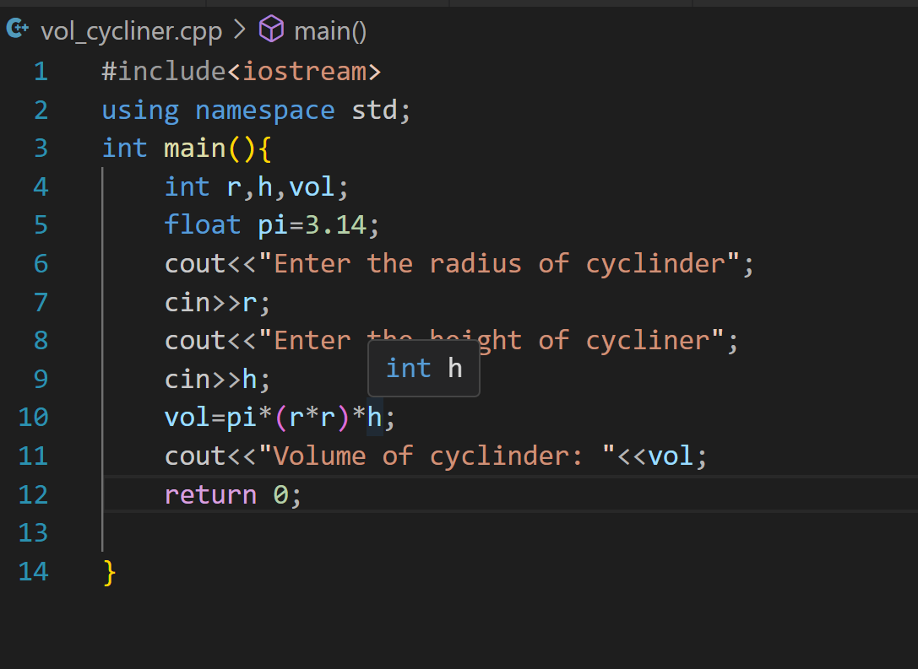
5. 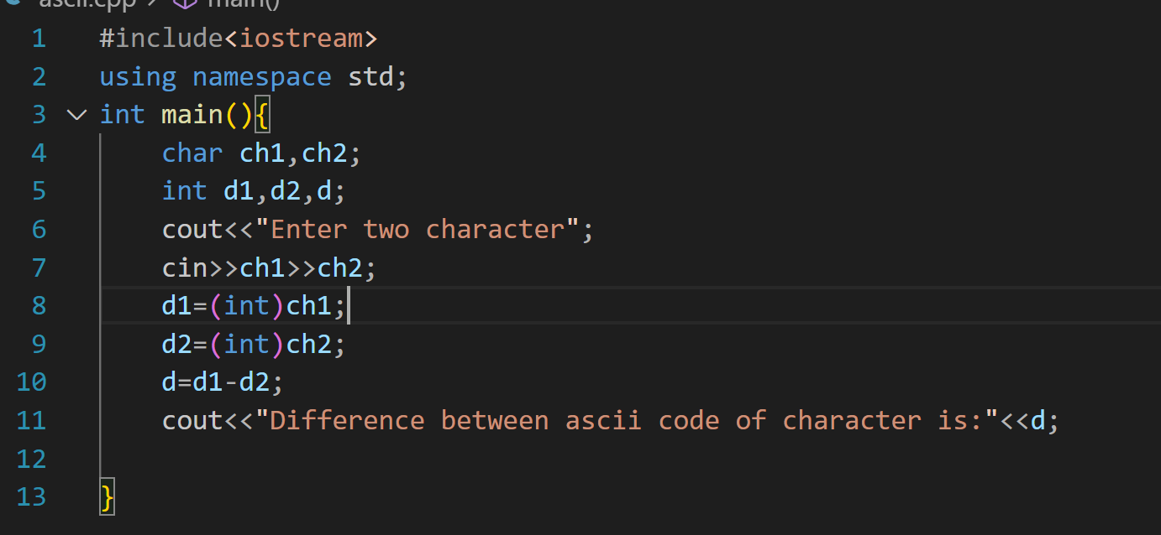
6. Output- 49